

**Project -Title: Homify**

**Submitted by**

Taukir Ahmad Raju

ID: 191-35-425

Department of Software Engineering

Daffodil International University

**Supervised by**

Afsana Begum

Assistant Professor & Coordinator M.Sc

Department of Software Engineering

Daffodil International University

This project report has been submitted in fulfillment of the requirements for the Degree of Bachelor of Science in Software Engineering.

© All right Reserved by Daffodil International University

Date of Submission: __th July 2023

**ABSTRACT**

Homify is a real estate app that connects homeowners who are looking to rent out their properties with potential renters. The app has two user ends, one for the public and one for homeowners. The public can see rental posts from homeowners and contact them through various means such as email, call, or messaging by creating a user account. Homeowners can store information about their properties, including bills, renter information, and make monthly bill invoices for renters. The app stores this information in a database and sends instant SMS to renters' contact numbers. Homeowners can view graphical representations of their property information and assign a manager to manage their dashboard if they have multiple properties.

Here are some of the key features of Homify:

* Easy to use interface for both homeowners and renters
* Secure database for storing property information
* Instant SMS notifications for renters
* Graphical representations of property information
* Ability to assign a manager to manage your dashboard

Homify is a convenient and secure way to rent out your property. With its easy-to-use interface and secure database, Homify makes it easy to find tenants and manage your rental properties.

Table of Contents

CHAPTER 1 5

INTRODUCTION 5

1.1 Purpose 5

1.2 Scope 5

1.3 Target Audience 5

1.4 Project Schedule 6

1.4.1 Release Plan And Milestone 6

CHAPTER 2 7

REQUIREMENT ANALTSIS 7

2.1 General user 7

2.1.1 Functional Requirements: 7

2.1.2 Non-Functional Requirements: 7

2.2 Homeowner 8

2.2.1 Functional Requirements: 8

2.2.2 Non-Functional Requirements: 8

2.3 Admin 9

2.3.1 Functional Requirements: 9

2.3.2 Non-Functional Requirements: 9

CHAPTER 3 10

SYSTEM OVERVIEW 10

3.1 System Architecture 10

3.2 Development Model 11

3.3 Use Case Diagram 11

Figure 3.3.1 Use Case Diagram for Homify 12

3.4 Activity Diagram 12

3.5 Sequence Diagram 18

3.6 Database Modeling 23

3.7 Technology Stack 23

CHAPTER 4 25

User Interfaces 25

4.1 Public User Interface 25

4.1.1 Property Listings 25

4.1.2 Search and Filters 26

4.1.3 Contact Homeowners 26

4.1.4 User Account 27

4.1.5 Live Chat 27

4.2 Homeowner Interface 28

4.2.1 Homeowner Dashboard 28

4.2.2 Property Management 28

4.2.3 Renter Management 28

4.2.4 Billing and Invoicing 29

4.2.5 Homeowner Profile 30

4.2.6 Home Information 30

4.2.7 Post Section 31

4.3 Admin Interface 31

4.3.1 Admin Dashboard 31

4.3.2 User Management 32

4.3.3 House Management 32

4.3.4 Post Management 33

CHAPTER 5 33

System Testing 33

5.1 Testing Phases 33

5.1 Testing Schedule 34

CHAPTER 6 35

Conclusion 35

Frequently Asked Questions (FAQ) 36

References 37

## CHAPTER 1

## INTRODUCTION

Welcome to Homify, a powerful real estate app designed to connect homeowners who are looking to rent out their properties with potential renters. Homify aims to simplify the process of finding and renting properties by providing a user-friendly platform that facilitates communication and streamlines property management.

### 1.1 Purpose

The purpose of the Homify app is to create a seamless and efficient way for homeowners to showcase their rental properties and for renters to easily find and connect with available properties. The app provides a centralized platform where homeowners can store property information, manage bills and renter details, and generate monthly invoices. At the same time, renters can search for rental properties and directly contact homeowners through various means, such as email, call, or messaging.

### 1.2 Scope

Homify focuses on the rental market, catering to both homeowners and renters. Homeowners can utilize the app to showcase their properties, manage rental-related information, and communicate with potential renters. Renters, on the other hand, can access the app to search for rental properties and initiate contact with homeowners. The app also includes an admin component that allows system administrators to manage and oversee the entire system, including user and property management, reporting, and analytics.

### 1.3 Target Audience

The Homify app targets two primary user groups:

1. Homeowners: Individuals who own properties and are interested in renting them out. They can use Homify to list their properties, manage rental details, generate invoices, and communicate with potential renters.
2. Renters: Individuals who are searching for rental properties. They can utilize Homify to browse available rental listings, contact homeowners, and initiate the rental process.

In addition, the app caters to system administrators who have the authority to manage and monitor the entire system, ensuring its smooth operation.

Homify aims to provide a user-friendly and efficient platform that benefits both homeowners and renters, simplifying the rental process and fostering effective communication between parties.

### 1.4 Project Schedule

Due to the short deadline, I created a schedule to ensure that the project was completed on time. The schedule outlined the tasks that needed to be completed and the actions that needed to be taken. I used Trello to track my progress.

### 1.4.1 Release Plan And Milestone

**Table: Release Plan**

|  |  |  |
| --- | --- | --- |
| **Activities** | **Duration in Week** | **Total Week** |
| Research | W1, W2 | 2 |
| Planning | W2, W3, W4, W5 | 4 |
| Design | W5, W6, W7, W8 | 4 |
| Development | W9, W10, W11, W12 | 4 |
| Testing | W13, W14 | 2 |
| Documentation | W14, W15, W16 | 3 |
| Software release | W17 | 1 |

## CHAPTER 2

## REQUIREMENT ANALTSIS

## General user

A general user is someone who uses a system or service without any special privileges.

### 2.1.1 Functional Requirements:

1. **View Rental Posts**: General users should be able to browse and view rental posts and property listings.
2. **Contact Homeowners**: General users should have the ability to contact homeowners who have listed their properties. This can be done through various means such as email, phone call, or messaging.
3. **User Account Creation**: General users should be able to create a user account in order to see invoices, make bill, conversation with homeowner and help center receive notifications, and have a personalized experience.

### 2.1.2 Non-Functional Requirements:

1. **Usability**: The app should provide an intuitive and user-friendly interface for General users to easily navigate and search for rental properties.
2. **Performance**: The browsing and search functionalities should be fast and responsive, providing a smooth user experience for general users.
3. **Compatibility**: The app should be compatible with various devices and browsers, ensuring that general users can access it from different platforms.
4. **Data Accuracy**: The app should ensure that the rental posts and property information displayed to general users are up-to-date and accurate.
5. **Security**: General users' personal information, such as email addresses and contact details, should be protected and kept confidential.

## Homeowner

A homeowner in the Homify app is an individual who owns a property and uses the app to connect with potential renters, manage property information, and streamline the rental process. They have the ability to list properties, track rental payments, generate invoices, and access insights into property performance.

### 2.2.1 Functional Requirements:

1. **Store Property Information**: Homeowners should be able to store detailed information about their properties, including property descriptions, amenities, location, and rental terms.
2. **Manage Bills and Renter Information**: Homeowners should have the ability to manage bills, track rental payments, and store information about renters, including their contact details and rental history.
3. **Generate Monthly Bill Invoices**: The app should provide functionality for homeowners to generate monthly bill invoices for renters, specifying the amount due, due date, and payment instructions.
4. **Graphical Representations**: Homeowners should have access to graphical representations and reports that provide insights into property performance, occupancy rates, rental income, and expense breakdowns.
5. **Assign Manager**: Homeowners with multiple properties should be able to assign a manager to each property, allowing the manager to access and manage property-related information.

### 2.2.2 Non-Functional Requirements:

1. **Security**: Homeowners' data, including property and rental information, should be securely stored and accessible only to authorized users.
2. **Usability**: The app should provide a user-friendly interface that allows homeowners to easily manage their property information, bills, and renters.
3. **Performance**: The app should be efficient and responsive, allowing homeowners to perform tasks quickly and without delays.
4. **Scalability**: The app should be scalable to accommodate homeowners with multiple properties and a growing number of renters.

## 2.3 Admin

Admin is a privileged user who has overall control and management authority over the system. They oversee user management, property listings, and system configuration. Admins have the ability to perform administrative tasks, generate reports, and monitor system activities to ensure the smooth functioning of the app.

### 2.3.1 Functional Requirements:

1. **System Management**: Admins should have the ability to manage and oversee the entire system, including user management, property listings, and system configuration.
2. **User and Property Management**: Admins should be able to manage user accounts, including creating, updating, and deleting accounts as necessary. They should also have the ability to manage property listings and perform administrative tasks related to properties.
3. **Reporting and Analytics**: The app should provide reporting and analytics capabilities to admins, allowing them to generate reports, monitor system activities, and gain insights into the performance of the platform.

### 2.3.2 Non-Functional Requirements:

1. **Security**: Admin accounts should have enhanced security measures and access control to protect sensitive system information and functionalities.
2. **Usability**: The admin interface should be user-friendly and provide a clear overview of the system, allowing admins to efficiently manage users, properties, and system settings.
3. **Performance**: The admin functionalities should be responsive and perform.

## CHAPTER 3

## SYSTEM OVERVIEW

### 3.1 System Architecture

The Homify app is built on a scalable and modular architecture that ensures efficient performance and easy maintenance. The system architecture consists of the following key components:

1. **Front-End**: The front-end of Homify is developed using HTML, CSS, JavaScript, React, Redux, Axios, and RTK Query. These technologies are used to create a dynamic and responsive user interface, allowing public users, homeowners, and administrators to interact with the app and access their respective features.
2. **Back-End**: The back-end of Homify is built using Node.js and Express, which provide a robust and efficient server-side environment. Authentication and authorization are implemented using technologies like JWT (JSON Web Tokens) and Passport.js. The back-end handles incoming requests, processes business logic, interacts with the database, and exposes a RESTful API to communicate with the front-end.
3. **Database**: Homify utilizes MongoDB as the database management system. MongoDB is a NoSQL database that offers flexibility, scalability, and fast data retrieval. It stores various data entities such as property information, user profiles, rental agreements, bills, and invoices. Additionally, Cloudinary is used for image storage, allowing seamless management and retrieval of property images.
4. **External Services**: Homify integrates external services like SMS gateways for instant notifications to renters and mapping services for location-based features. These services enhance the functionality of the app and provide a seamless user experience.

### 3.2 Development Model

The development of the Homify app follows the Agile development model. Agile methodologies, such as Scrum or Kanban, are utilized to deliver functionality in iterative and incremental cycles. This approach allows for flexibility, frequent feedback, and collaboration among the development team, stakeholders, and users. Agile practices, including user stories, sprints, and regular retrospectives, ensure that the app meets the evolving needs of the users and stakeholders.

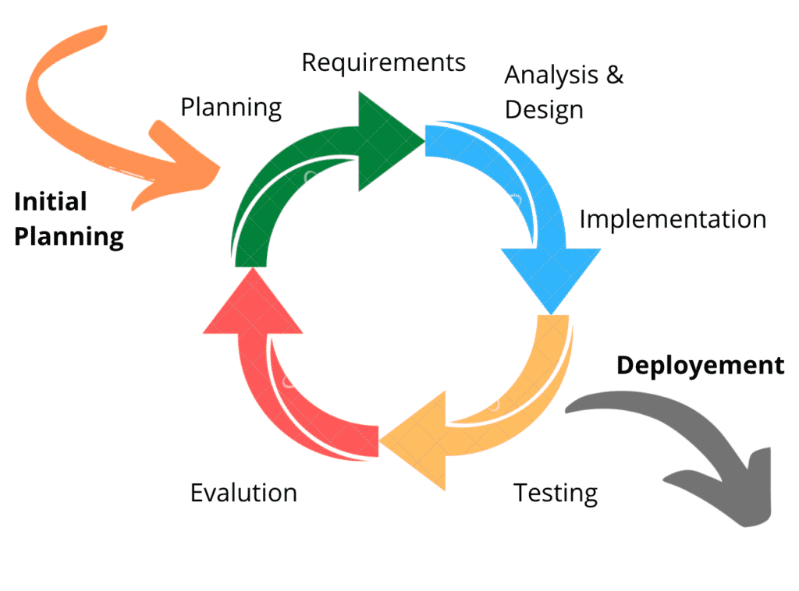

### 3.3 Use Case Diagram

A use case diagram illustrates the interactions and relationships between the actors (users and the system) and the various use cases (functionality) within the Homify app. It provides an overview of the app's functionalities and the actors involved. The use case diagram helps in identifying the different user roles, their interactions, and the core features provided by the app.

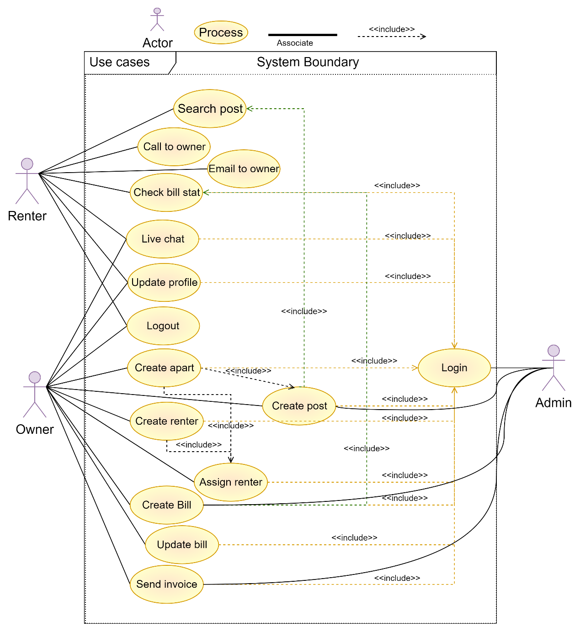

### Figure 3.3.1 Use Case Diagram for Homify

### 3.4 Activity Diagram

An activity diagram showcases the flow of activities or processes within the Homify app. It visually represents the steps, decisions, and actions taken during specific processes, such as user registration or property listing. The activity diagram provides a clear understanding of the workflow and helps identify any potential bottlenecks or areas for improvement.

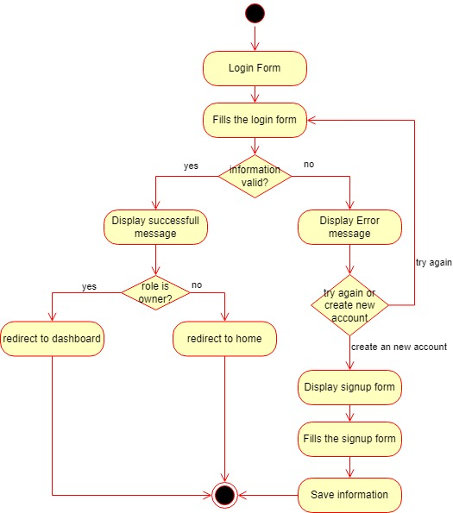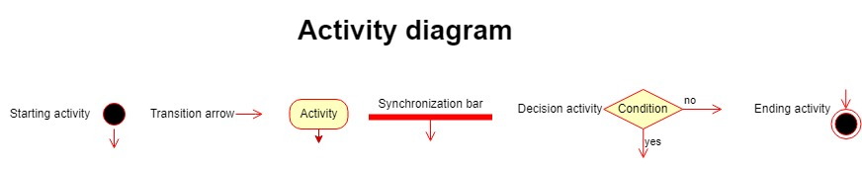

Figure 3.4.1 login & registration

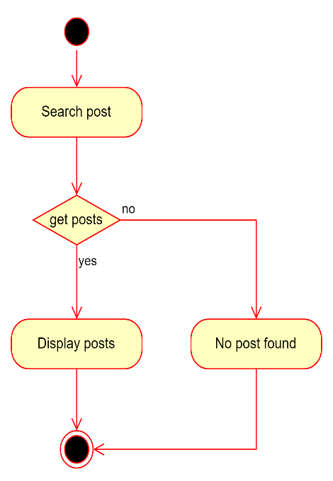

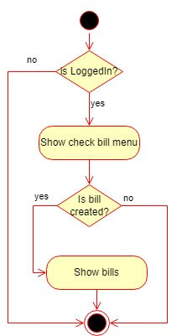

Figure 3.4.2 search post Figure 3.4.3 check bill

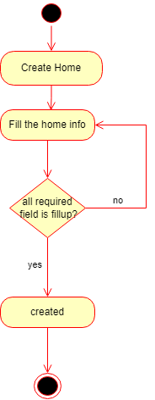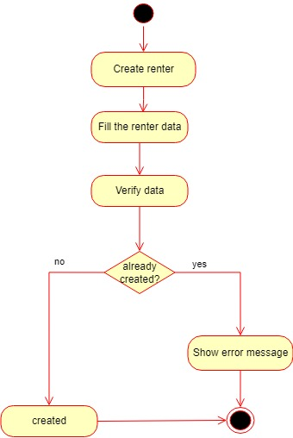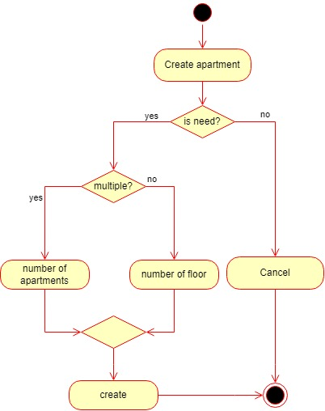

Figure 3.4.6 create renter

Figure 3.4.5 create apartment

Figure 3.4.4 create home

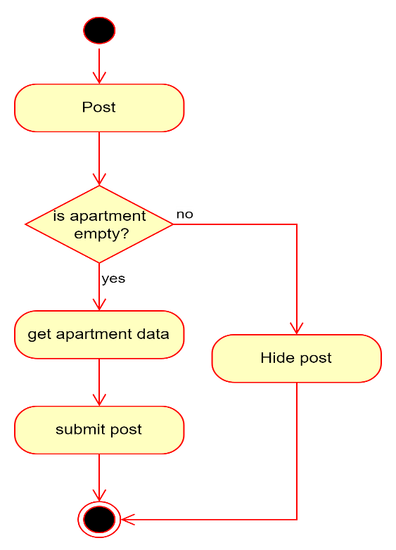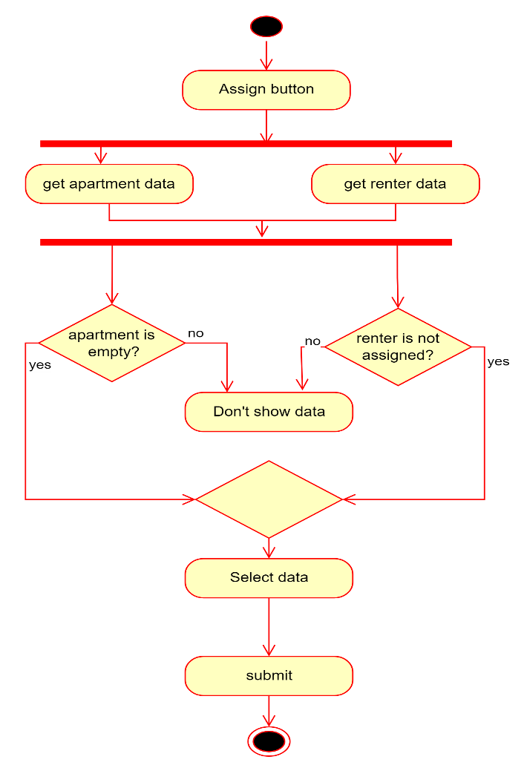

Figure 3.4.8 post empty apartment

Figure 3.4.7 assign renter

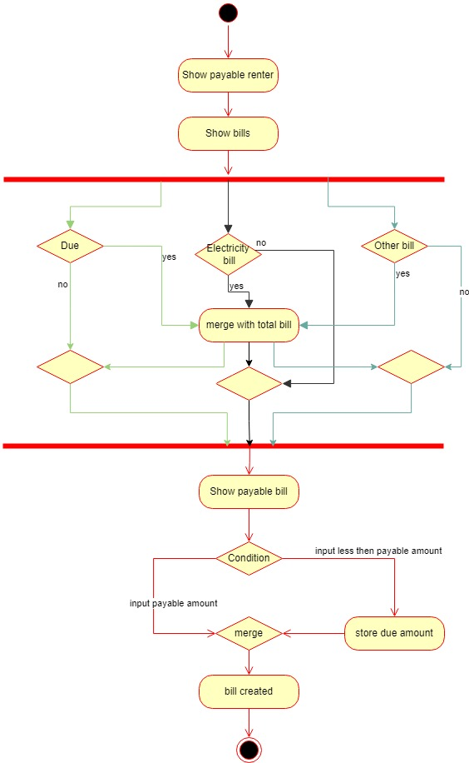

Figure 3.4.9 make bill

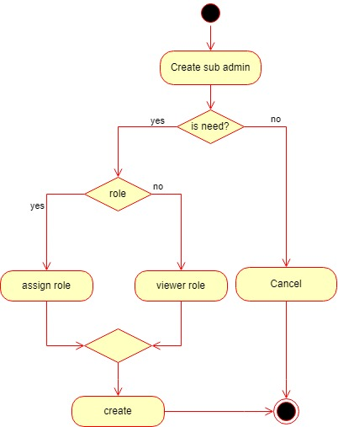

Figure 3.4.10 create admin

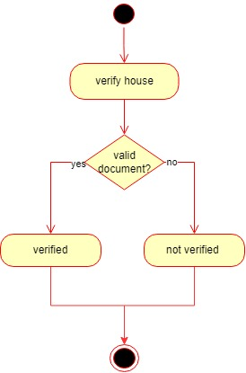

Figure 3.4.11 verify house

### 3.5 Sequence Diagram

A sequence diagram presents the chronological order of interactions between various components or actors within the Homify app. It illustrates how different elements communicate and exchange information during specific scenarios, such as a user contacting a homeowner or a homeowner generating a monthly bill invoice. The sequence diagram helps visualize the interactions and understand the system behavior.

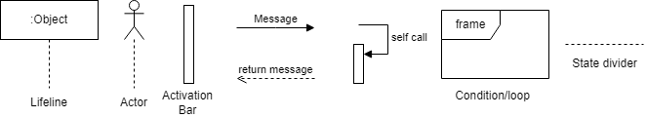

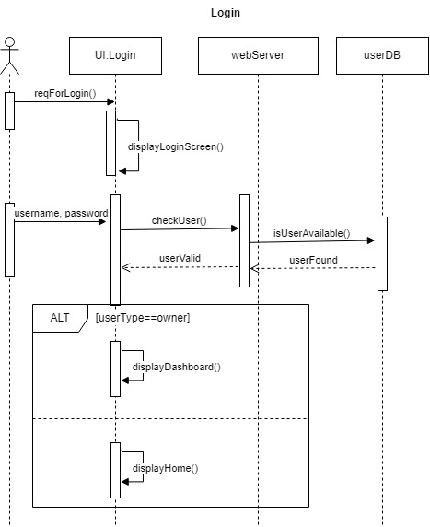

Figure 3.5.1 login

Figure 3.5.2 registration

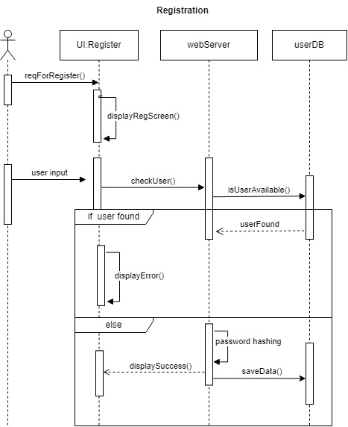

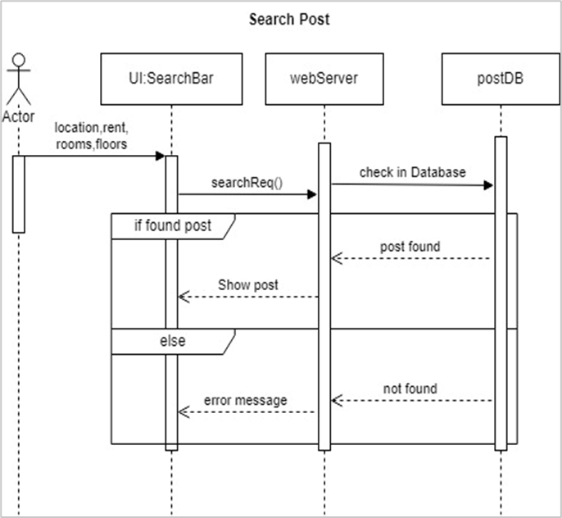

Figure 3.5.3 search post

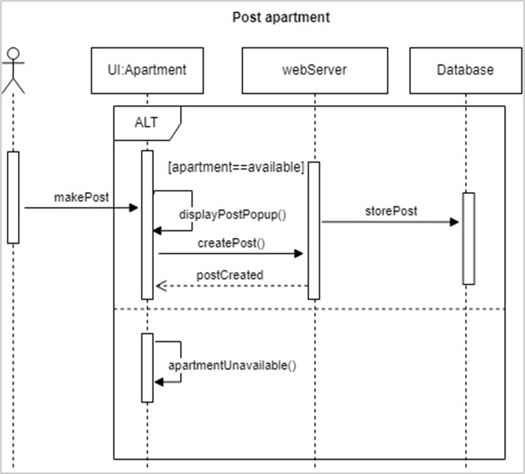

Figure 3.5.4 post apartment

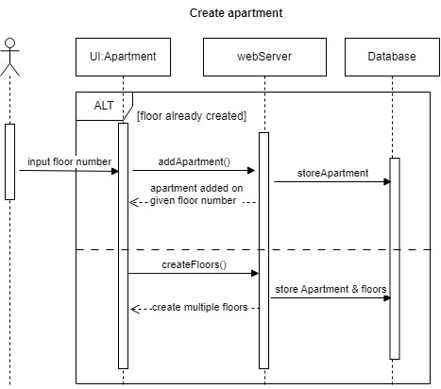

Figure 3.5.5 create apartment

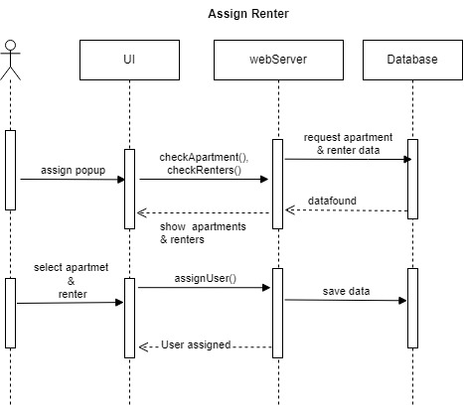

Figure 3.5.6 assign renter

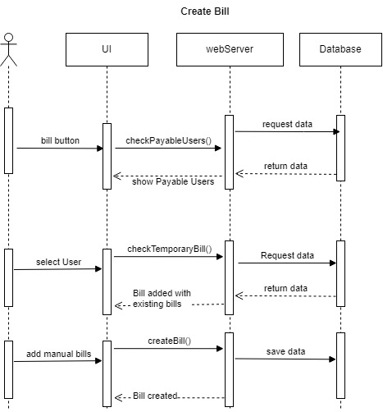

Figure 3.5.7 create bill

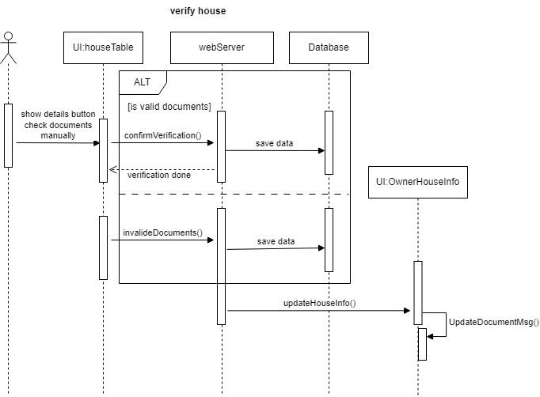

Figure 3.5.8 verify house

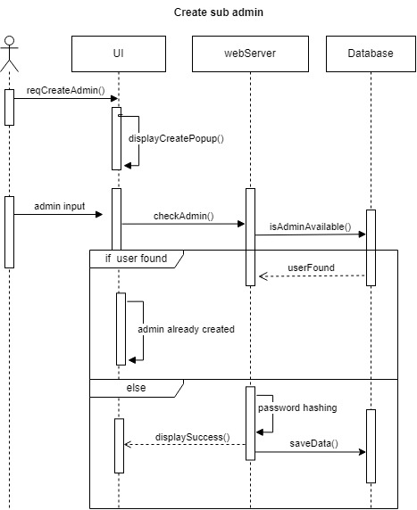

Figure 3.5.9 create admin

### 3.6 Database Modeling

Homify's database is modeled using MongoDB's document-based approach. It employs collections and documents to organize and store data. The data model defines the structure and relationships between different entities, such as renter, owner, house, address, bill, posts. MongoDB's flexible schema allows for easy adaptation to evolving requirements and efficient querying of data.

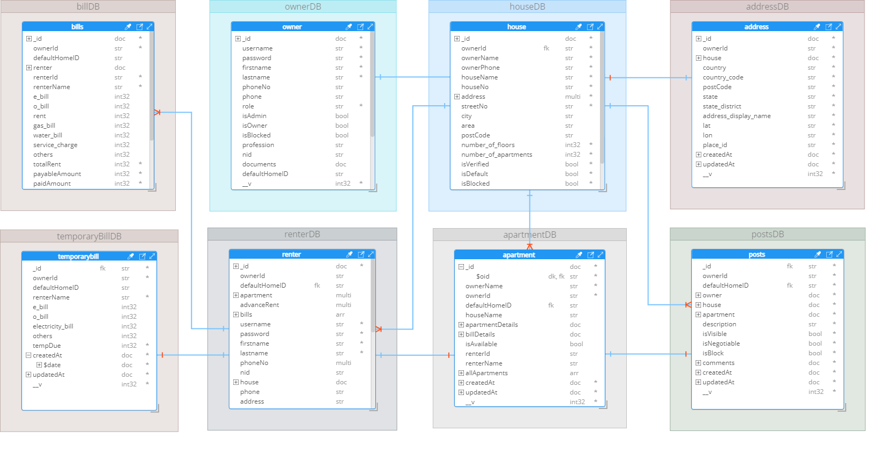

### 3.7 Technology Stack

**Front-End:**

* HTML
* CSS
* Tailwindcss
* Mantine
* JavaScript
* React
* React table
* Redux
* Axios
* RTK Query

**Back-End:**

* Node.js
* Express
* JWT (JSON Web Tokens)
* Passport.js
* RESTful API

**Database:**

* MongoDB (NoSQL database)

**External Services:**

* Cloudinary (Image storage)
* SMS gateway (for instant notifications)
* Socket.io (for instant message and notifications)

## CHAPTER 4

## User Interfaces

### 4.1 Public User Interface

The public user interface is designed for users who are searching for rental properties. It provides the following features and functionalities:

### 4.1.1 Property Listings

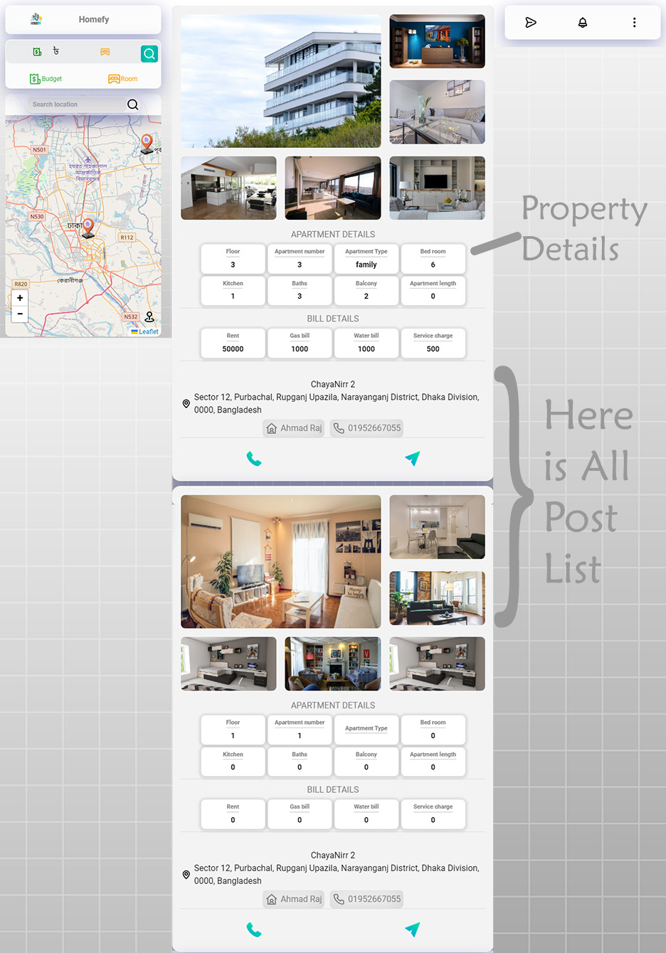 Users can browse through a list of available rental properties. The listings display essential information such as property location, size, amenities, rental price, and images.

### 4.1.2 Search and Filters

Users can perform searches based on their preferences, such as location, rental price range, property type etc. The app provides filters to narrow down the search results and find properties that match their criteria.

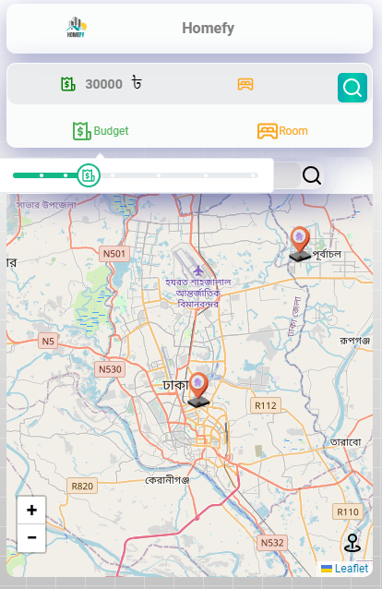

### 4.1.3 Contact Homeowners

Users can view detailed property descriptions and contact the homeowners for more information. Contact options include email, phone calls, and messaging.



### 4.1.4 User Account

Public users can create an account to save their personal information, track their transaction history with homeowners, and receive notifications from property owner and many more.

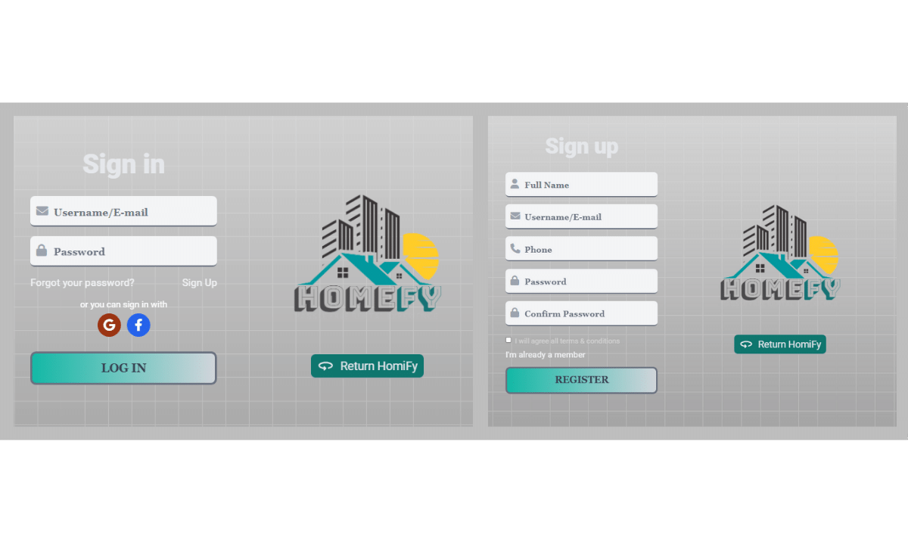

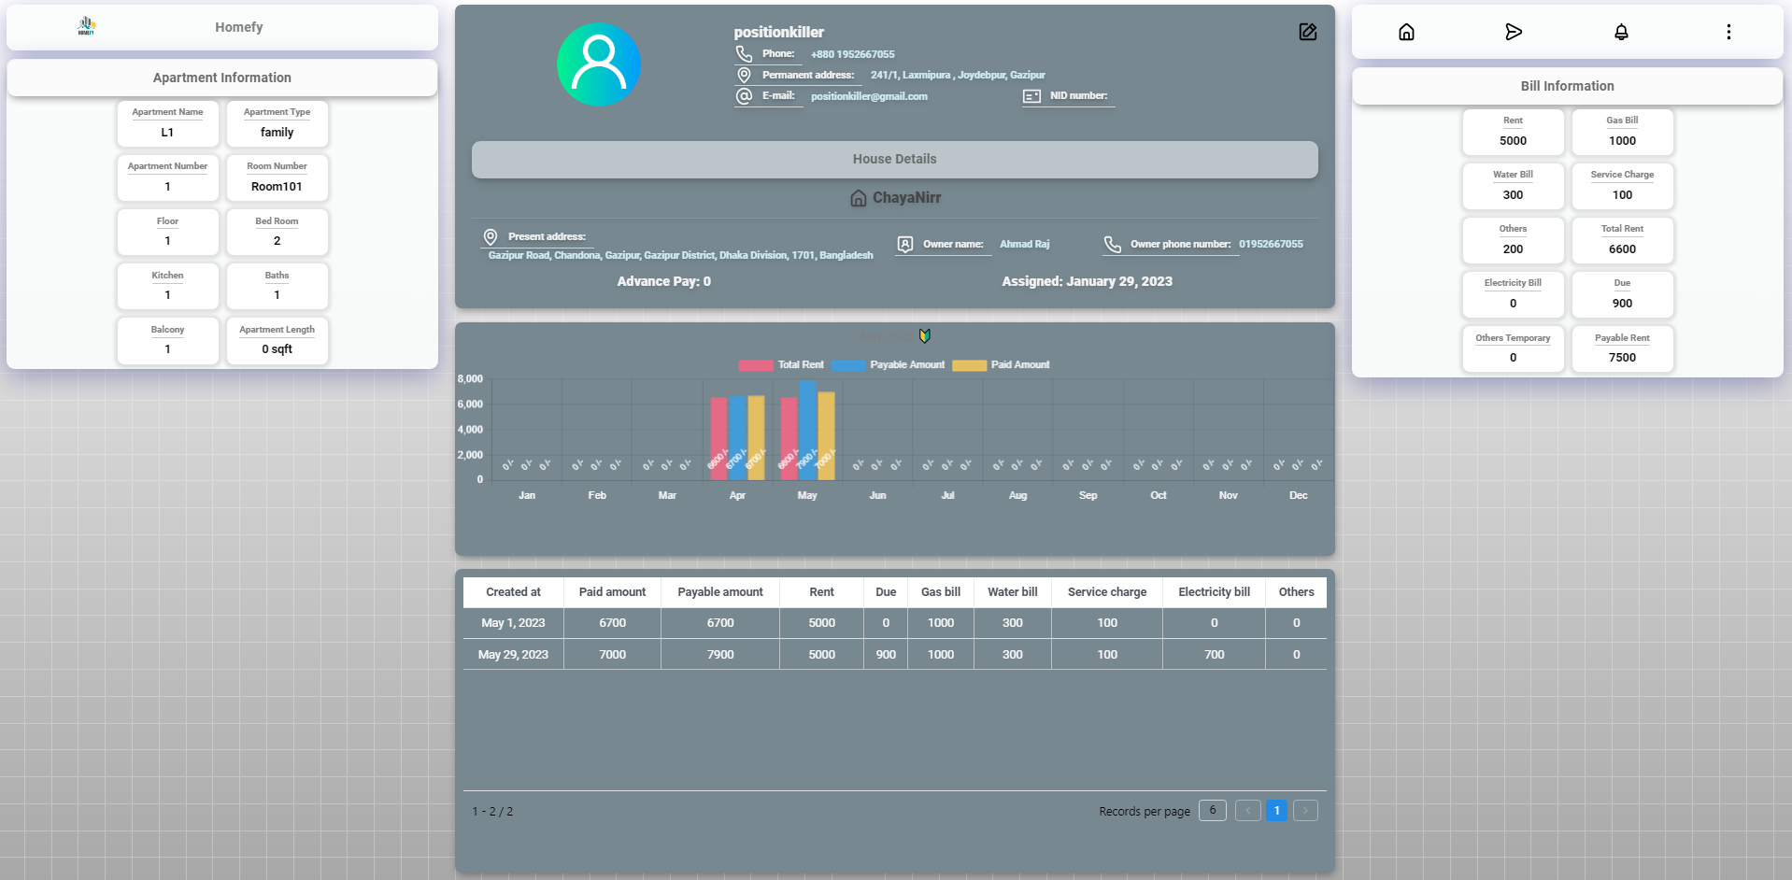

### 4.1.5 Live Chat

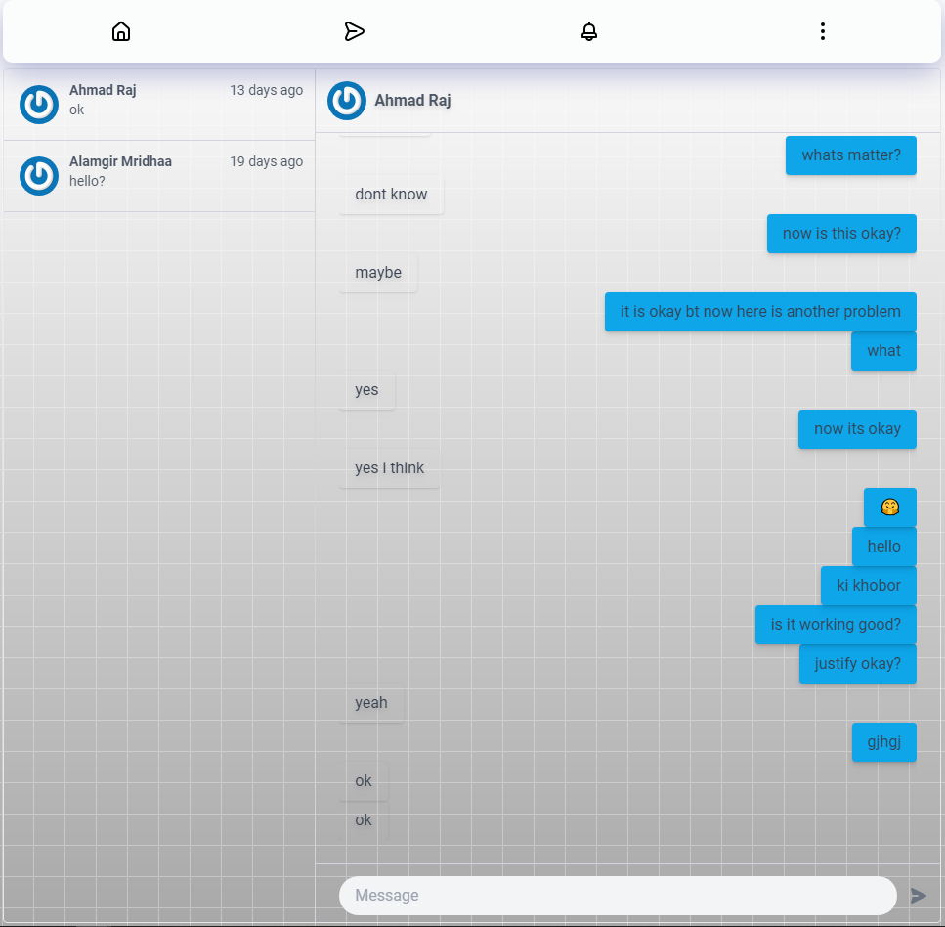Registered users can live chat with home owner and help center.

### 4.2 Homeowner Interface

The homeowner interface is designed for property owners who want to rent out their properties. It provides the following features and functionalities:

### 4.2.1 Homeowner Dashboard

The homeowner dashboard in the Homify app offers a comprehensive overview of the property-related information and statistics. It provides graphical representations and visualizations to help homeowners analyze and track various aspects of their rental properties.

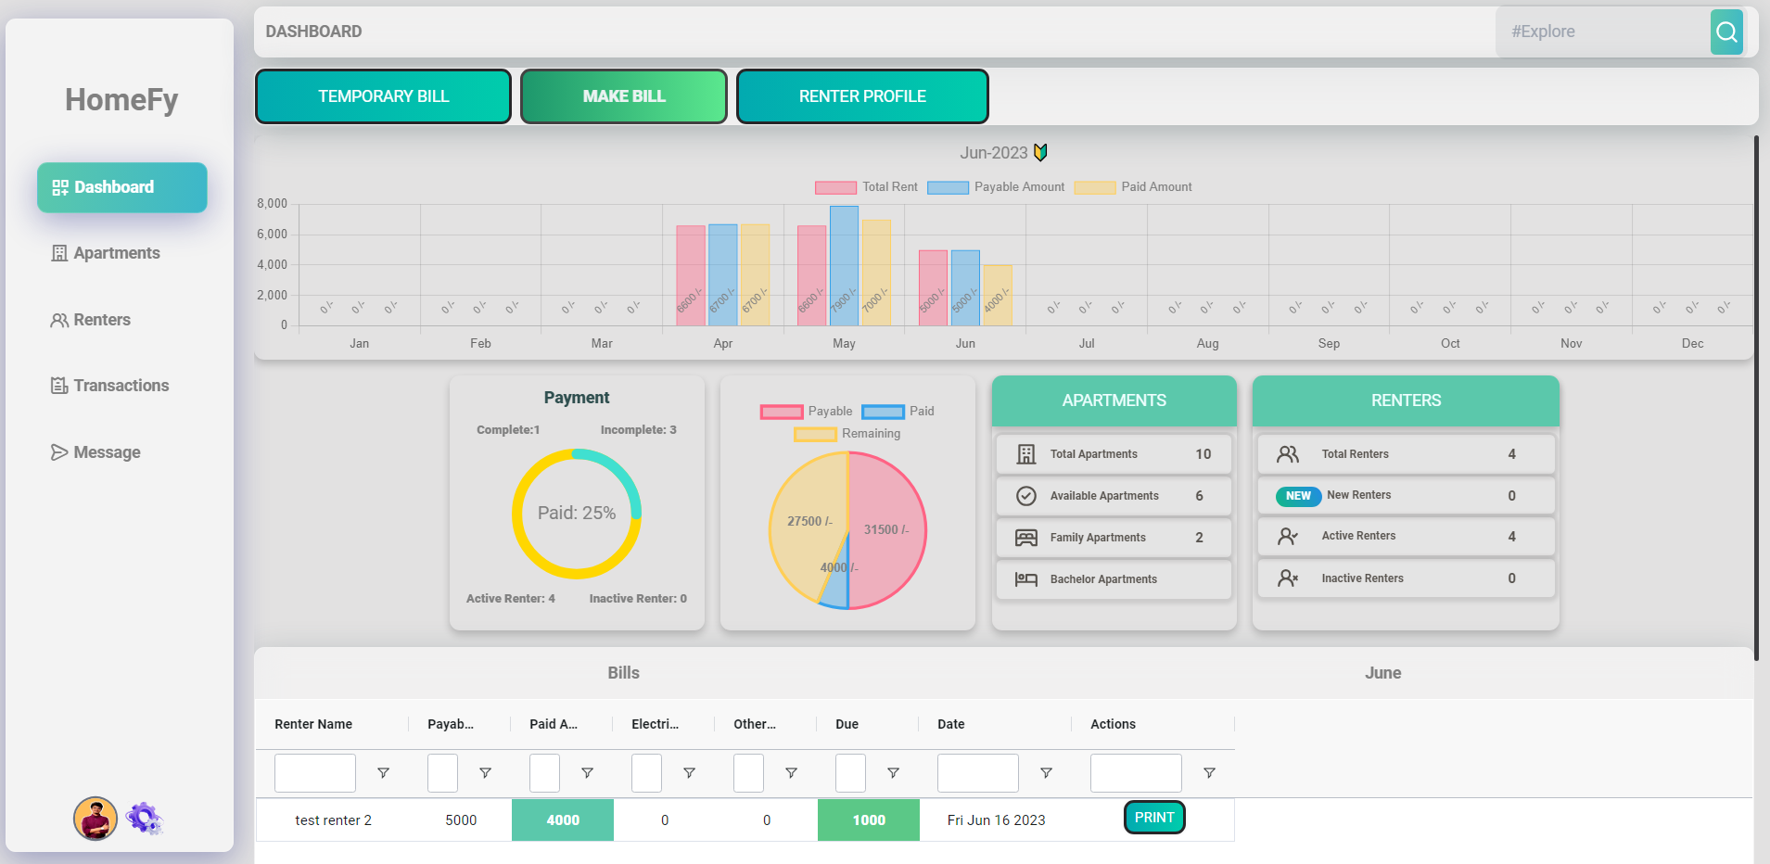

### 4.2.2 Property Management

Homeowners can create and manage listings for their properties. They can input property details such as location, size, rental terms, and upload images to showcase the property.

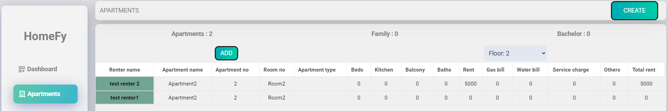

### 4.2.3 Renter Management

Homeowner can manage renter, including creating new accounts, assigning or unassigning apartment and remove from home.

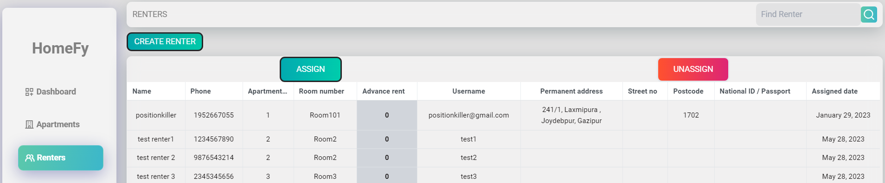

### 4.2.4 Billing and Invoicing

Homeowners can track rental payments, generate monthly bill invoices for renters, and manage bills associated with the property. They can view payment histories and send invoice to renters by SMS.

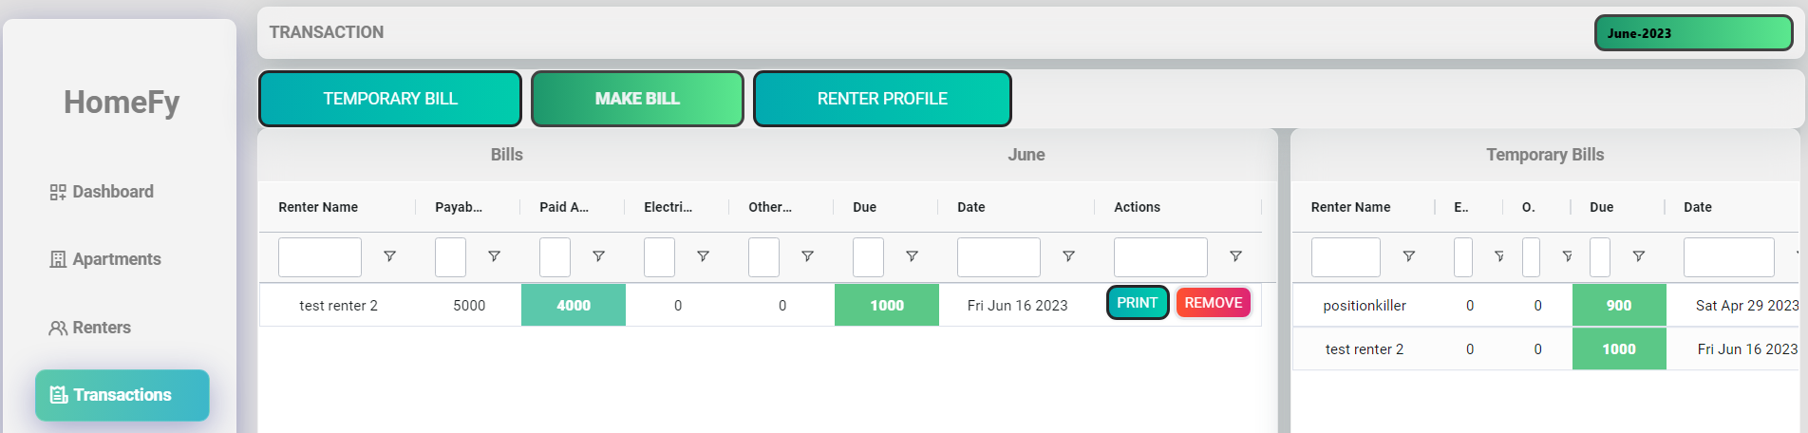

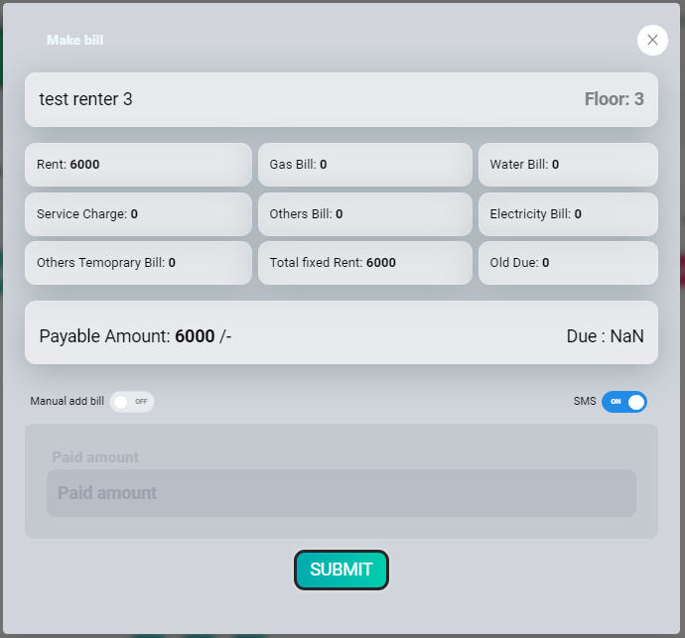

### 4.2.5 Homeowner Profile

Owner have a personal profile section where they can assign a manager to handle the day-to-day management tasks.

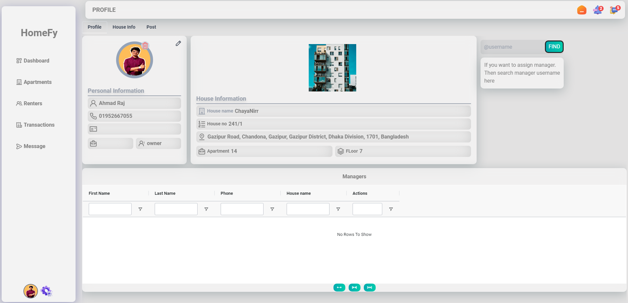

### 4.2.6 Home Information

In home information section homeowner can create multiple home and active single home at a time. Then under this activate home they can manage all things.

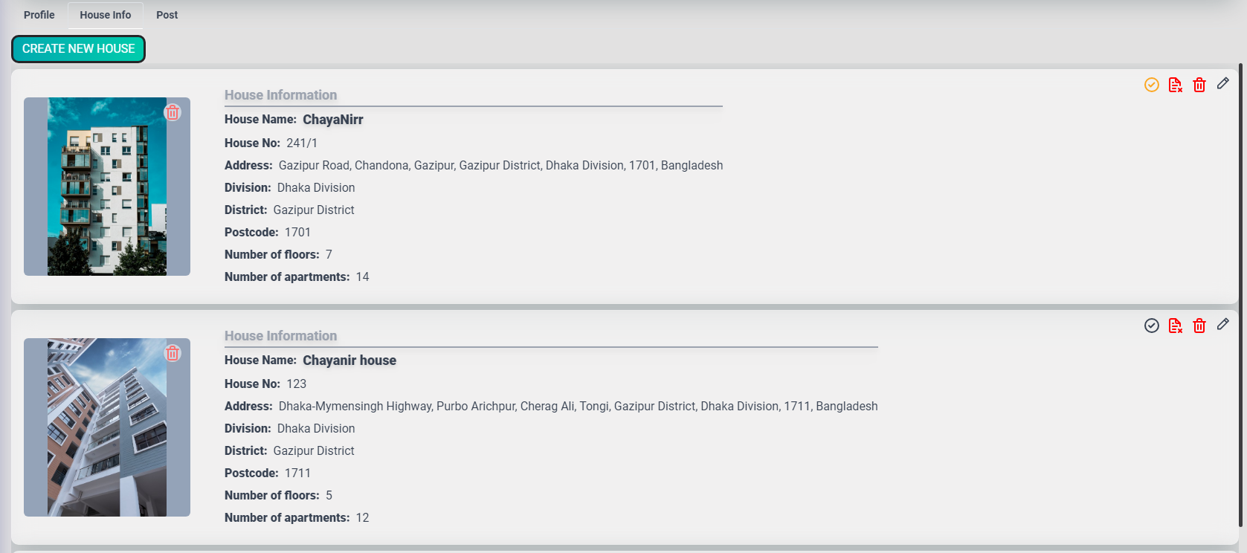

### 4.2.7 Post Section

In here all posts are shown under specific home. Homeowner can update active/inactive or delete post from here.

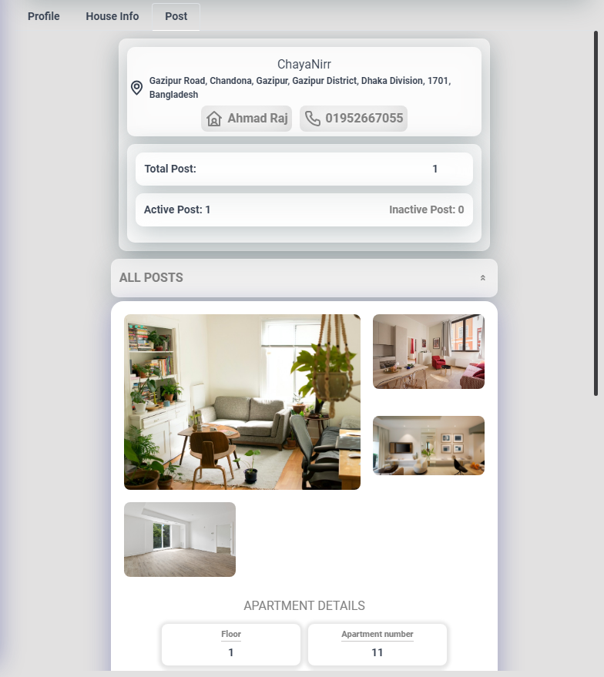

### 4.3 Admin Interface

### 4.3.1 Admin Dashboard

The admin dashboard shows all reports and access analytics related to property listings, user activities, and system performance. These insights help in monitoring the app's usage, identifying trends, and making data-driven decisions.

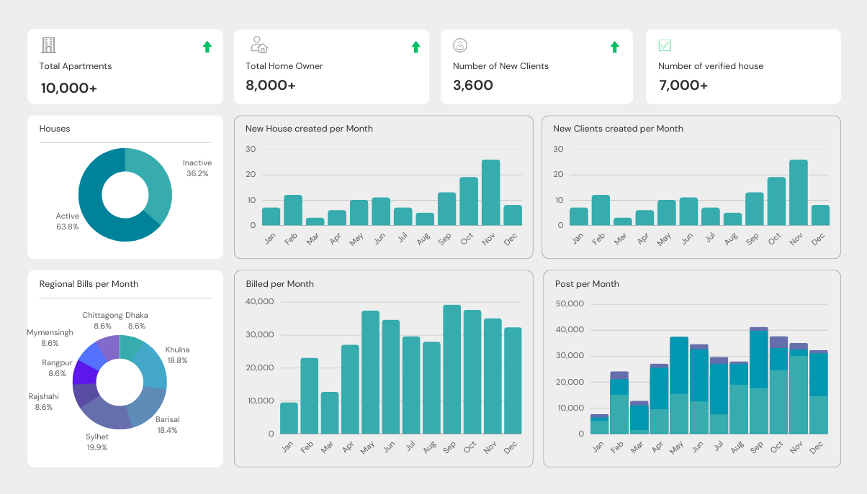

### 4.3.2 User Management

Admin can manage all users. They can block and unblock users for their activities and if some user faces any problem, then they can check their activity.

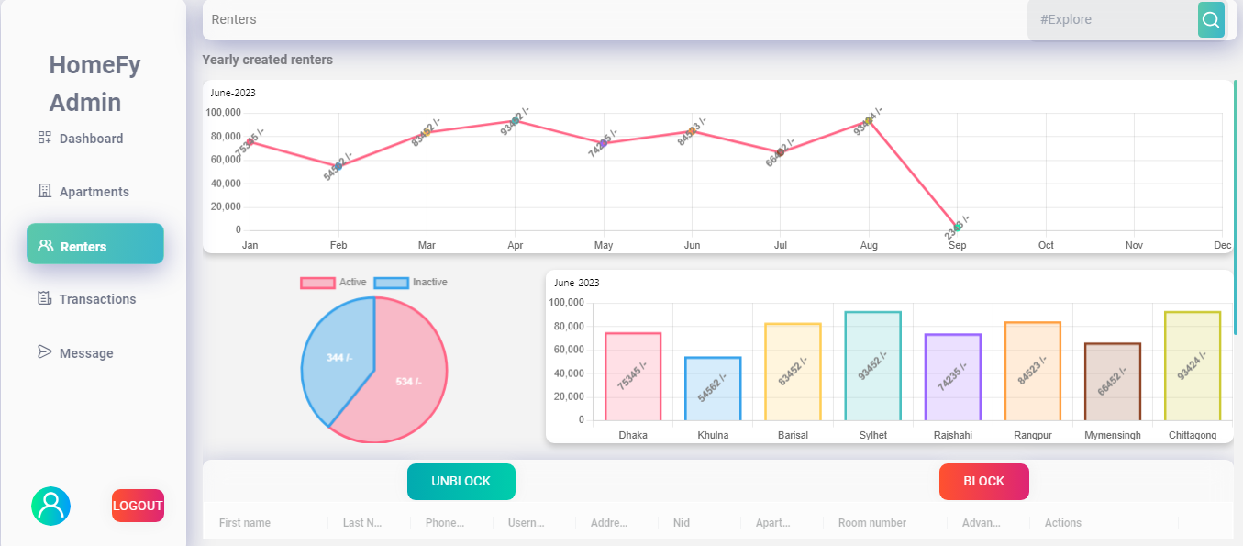

### 4.3.3 House Management

In this section admin can saw all information about houses and they can verify new houses. If submitted document is valid then they approve the house as a verified house.

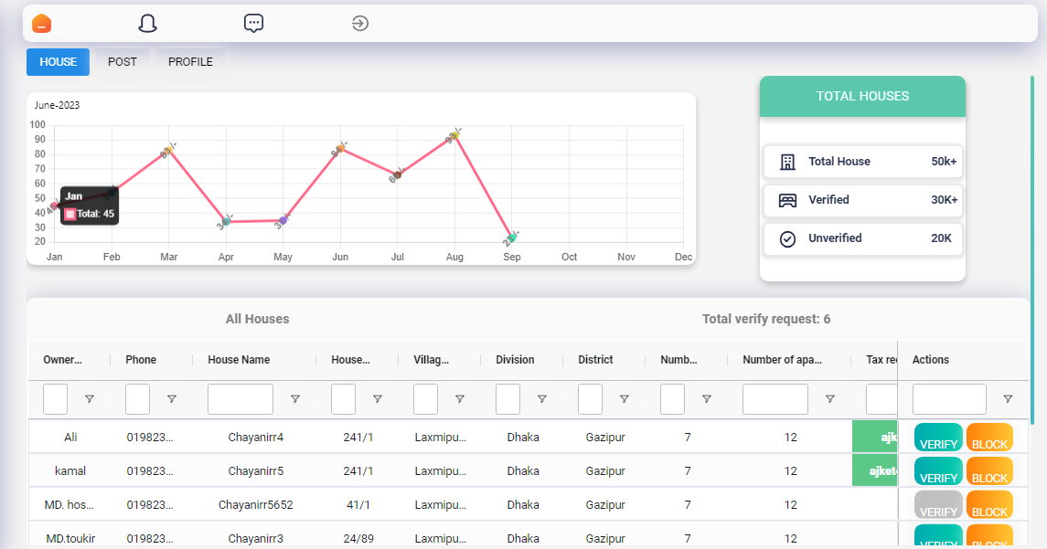

### 4.3.4 Post Management

Admin can check all post. If any one makes a fake post, then they can block it form this section. Also, they can saw all posts activates form here.

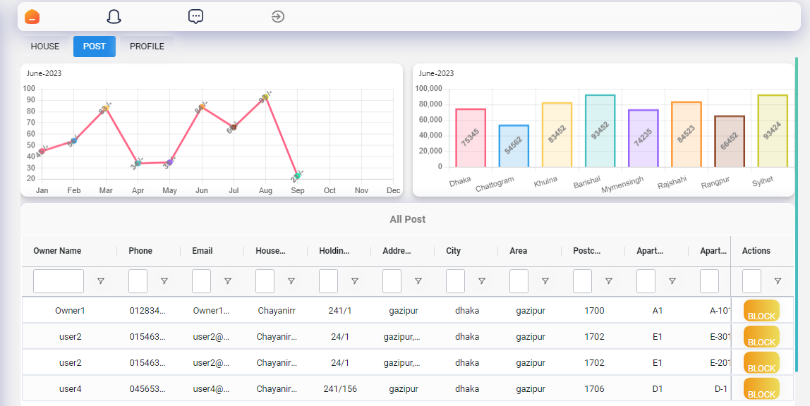

The user interfaces in the Homify app are designed to cater to the specific needs of public users, homeowners, and administrators, providing them with a seamless and intuitive experience while interacting with the app and managing their respective tasks.

## CHAPTER 5

## System Testing

### 5.1 Testing Phases

System testing is a crucial phase in the development process of the Homify app. It ensures that all the components and functionalities of the system are working as intended, meeting the specified requirements, and delivering a high-quality user experience. The following testing approaches and techniques are employed:

1. **Unit Testing**: Unit tests are conducted to verify the correctness of individual components or modules in isolation. This testing approach ensures that each unit of code functions as expected. Unit tests are written for both front-end and back-end components using appropriate testing frameworks and libraries.
2. **Integration Testing**: Integration testing is performed to validate the proper interaction and communication between different modules and components of the Homify app. It ensures that the integrated system functions as a cohesive unit and that data flows correctly between various layers and services.
3. **Functional Testing**: Functional testing focuses on testing the app's functionalities from the perspective of different user roles, including public users, homeowners, and administrators. It involves verifying that all user actions, such as property search, property listing creation, renter communication, and bill generation, work correctly and produce the expected results.
4. **User Interface (UI) Testing**: UI testing is conducted to ensure that the user interfaces of the Homify app are visually appealing, responsive, and provide a seamless user experience. It involves verifying the layout, navigation, forms, buttons, and other UI elements across different devices and screen sizes.
5. **Performance Testing**: Performance testing is carried out to evaluate the app's performance under various load conditions. It measures response times, throughput, resource utilization, and scalability to identify any performance bottlenecks or areas for optimization. Performance testing helps ensure that the app can handle a large number of concurrent users and deliver a smooth user experience.
6. **Security Testing**: Security testing is performed to identify and mitigate potential vulnerabilities in the Homify app. It involves testing for common security issues such as authentication and authorization flaws, input validation vulnerabilities, and protection against common attacks like SQL injection and cross-site scripting (XSS).
7. **Usability Testing**: Usability testing focuses on evaluating the app's ease of use and user satisfaction. It involves gathering feedback from real users to assess how well the app meets their needs, whether the user interfaces are intuitive and user-friendly, and if any improvements or adjustments are needed to enhance the overall usability.
8. **Regression Testing**: Regression testing is conducted after implementing new features, bug fixes, or modifications to ensure that the existing functionalities have not been affected. It involves retesting previously tested scenarios to confirm that the changes have not introduced any unintended side effects.

### 5.1 Testing Schedule

|  |  |
| --- | --- |
| **Test Phase** | **Time** |
| Planning | 1 W |
| Unit Testing | During development time |
| Component Testing | During development time |
| UI Testing | 1W |
| Usability Testing | 3 Days |
| Performance Testing | 3 Days |
| Database Testing | 1w |
| Performance Testing | 1w |
| Compatibility Testing | 1w |
| Security Testing | 2w |

## CHAPTER 6

## Conclusion

In conclusion, Homify is a real estate app that aims to connect homeowners looking to rent out their properties with potential renters. It provides a convenient platform for users to search for rental properties, communicate with homeowners, and manage rental-related tasks. With its user-friendly interfaces, comprehensive features, and robust functionality, Homify offers a seamless and efficient experience for both public users and homeowners.

While Homify has been successful in addressing the needs of homeowners and renters, it does have some limitations. One notable limitation is the absence of an online payment system. Currently, Homify does not facilitate online payment transactions between homeowners and renters. However, users can still use traditional payment methods such as cash, checks, or bank transfers to manage rental payments. Integrating an online payment system in the future would enhance the convenience and security of the rental process.

Despite this limitation, Homify has a promising future scope. Some potential areas for expansion and improvement include:

1. **Online Payment Integration**: Incorporating a secure online payment system would allow homeowners and renters to manage rental payments directly through the app, providing a seamless and convenient experience.
2. **Enhanced Communication Features**: Introducing additional communication features such as in-app messaging or video calls would further facilitate interaction between homeowners and renters, enabling swift and efficient communication.
3. **Advanced Property Management Tools**: Expanding the homeowner dashboard to include advanced property management tools, such as maintenance request tracking, document management, and tenant screening, would empower homeowners to efficiently manage their rental properties.
4. **Localization and International Expansion**: Considering localization features and expanding the app's availability to international markets would cater to a broader user base and accommodate diverse rental requirements.

By addressing these areas of improvement and embracing new technologies, Homify can continue to evolve and deliver an exceptional rental experience for users, solidifying its position as a leading real estate app.

In summary, Homify has successfully provided a user-friendly and efficient platform for homeowners and renters to connect and manage rental properties. While it currently lacks an online payment system, there are exciting opportunities for future enhancements and expansions. By continuously refining its features and addressing user needs, Homify has the potential to become a comprehensive and indispensable tool for the real estate rental market.

## Frequently Asked Questions (FAQ)

**Q1: How can I search for rental properties on Homify?**

A: To search for rental properties, simply go to the Homify app and use the search bar or filters to specify your preferences such as location, rental price range, property type, and amenities. The app will display a list of available properties that match your criteria.

**Q2: How can I contact a homeowner regarding a property listing?**

A: Once you find a property of interest, you can contact the homeowner by clicking on the property listing. You will find contact options such as email, phone number, or messaging. Choose the preferred contact method and reach out to the homeowner for further information or to schedule a property viewing.

**Q4: How do I create a property listing as a homeowner?**

A: If you are a homeowner looking to rent out your property, you can create a property listing by logging into your Homify account and accessing the homeowner dashboard. From there, you can provide property details such as location, size, amenities, rental terms, and upload images to showcase your property.

**Q5: How can I track rental payments and manage bills as a homeowner?**

A: Homify provides a billing and invoicing feature for homeowners. You can track rental payments, generate monthly bill invoices for renters, and manage bills associated with your property through the homeowner dashboard. The dashboard will display payment histories, outstanding bills, and upcoming payment reminders.

**Q6: Can I assign a manager to handle my property if I have multiple properties?** A: Yes, if you have multiple properties, you can assign a manager to assist you with property management tasks. The manager will have access to your homeowner dashboard and can help with property listings, communication with renters, and other rental-related activities.

**Q7: How secure is my personal information on Homify?**

A: Homify takes the security and privacy of user information seriously. We implement robust security measures and follow industry best practices to protect your personal data. We do not share your information with third parties without your consent. For more details, please refer to our Privacy Policy.

**Q8: What should I do if I encounter an issue or have a technical problem on Homify?**

A: If you encounter any issues or have technical problems while using Homify, you can reach out to our customer support team. We have a dedicated support channel where you can report the problem and receive assistance. Our team will promptly address your concerns and provide the necessary support.

These are just a few examples of common user queries that can be included in the FAQ section of the Homify app. The FAQ section serves as a helpful resource for users, addressing their most frequently asked questions and providing them with quick and accurate answers to enhance their experience with the app.

## ReferencesTop of Form

During the development of the Homify app, the following resources and references were utilized:

1. Agile Manifesto: <https://agilemanifesto.org/>
   * The Agile Manifesto was referred to for understanding the principles and values of the Agile development model, which guided the development process of the Homify app.
2. React Documentation: <https://reactjs.org/docs>
   * The official React documentation was used as a reference to understand React's concepts, components, and best practices, which played a crucial role in building the front-end of the Homify app.
3. Node.js Documentation: <https://nodejs.org/en/docs/>
   * The Node.js documentation was referenced to explore Node.js capabilities, APIs, and modules, which formed the foundation of the Homify app's back-end development.
4. MongoDB Documentation: <https://docs.mongodb.com/>
   * The MongoDB documentation provided insights into MongoDB's document-oriented database system, helping in designing and implementing the database structure of the Homify app.
5. Cloudinary Documentation: <https://cloudinary.com/documentation>
   * The Cloudinary documentation was consulted to understand the features and integration options for storing and managing images in the cloud, which was utilized for image storage in the Homify app.
6. HTML, CSS, JavaScript Documentation:
   * Standard web development documentation and references were utilized to implement HTML, CSS, and JavaScript features, ensuring the app's responsiveness, styling, and interactivity.
7. Redux Documentation: <https://redux.js.org/>

* The Redux documentation served as a valuable resource for understanding the concepts and implementation of Redux, a state management library used in the Homify app. It provided guidance on managing application state, actions, reducers, and store configuration.

1. Tailwind CSS Documentation: <https://tailwindcss.com/docs>

* The Tailwind CSS documentation was used as a reference for understanding the utility-first CSS framework and its usage in the Homify app. It provided detailed documentation on utility classes, responsive design, customizing styles, and optimizing CSS workflow.

1. OpenAI's ChatGPT: <https://www.openai.com/>

* OpenAI's ChatGPT, a language model powered by GPT-3.5, was utilized as a valuable resource throughout the documentation process for the Homify app. ChatGPT provided real-time assistance, generated content, and answered questions related to various aspects of the project, including system overview, requirements analysis, technology stack, and more.